
Department of Computer Science (PG) Practical Record on
ADVANCED DATABASE MANAGEMENT SYSTEM PRACTICAL
(25MCD1L211)
I Semester MCA

For the academic year 2025 – 2026 Submitted by
ADYAPRANA PRADHAN
25MCAC57

KRISTU JAYANTI (DEEMED TO BE UNIVERSITY)
K. Narayanapura, Kothanur Post, Bengaluru 560077

DEPARTMENT OF COMPTUER SCIENCE (PG)

Master of Computer Applications



This is to certify that ADYAPRANA PRADHAN bearing roll number 25MCAC57 has satisfactorily completed the practical programs for the course ADVANCED DATABASE MANAGEMENT SYSTEM PRACTICAL, 25MCD1L211 during
the academic year 2025 – 2026.

Date: Faculty incharge

Head of the Department
Examiners (Name & Signature)

- Center: Kristu Jayanti University
Date:

Table of Contents
 | SI.  No | Date | Program title | Page No.
 | 1. | 12-08-2025 | Perform the following DDL and DML operations  - Create table  - Alter table  - Drop Table  - Insertion  - Deletion  - Modify  - Update  - View | 1-4
 | 2. | 19-08-2025 | Implementation of different types of function with  suitable examples  - Number function  - Aggregate Function  - Character Function  - Conversion Function Date Function. | 5-9
 | 3. | 19-08-2025 | Implementation of different types of operators in SQL  - Arithmetic Operators  - Logical Operators  - Comparison Operator  - Special Operator  - Set Operation | 10-13
 | 4. | 26-08-2025 | Create a table for Employee details with Employee Number as primary key and following fields: Name, Designation, Gender, Age, Date of Joining and Salary.  - Insert at least ten rows | 14-16

- Group By & having clause
- Order by clause
- Indexing
 | 5. | 29-08-2025 | - Create Student, Subject, Internal_Mark and  External_Mark table and perform the following operations  - Add, edit, delete student records.  - Add, edit, delete subject details  - Input internal and external marks for students in various subjects and assessments.  - View individual student marks, subject-wise marks, or aggregated results. | 17-22
 | 6. | 09-09-2025 | Create appropriate table and perform the following string  operations.  - Concatenate first name and last name of students  - Convert employee names to uppercase and lowercase  - Find employees whose names start with ‘A’  - Format phone numbers with hyphen (e.g., 9876543210 → 98765-43210)  - Capitalize only the first letter of names (title case)  - Create email IDs using student first name and roll number  - Validate email format using string pattern | 23-27
 | 7. | 12-09-2025 | Create appropriate table and perform the following Join  operations.  - List employee names with their department names  - Display all employees and their department names, including those without a department  - Show all departments and the employees in them, even if no employees exist  - List employees along with their manager names  - List student names, course names, and faculty names | 28-34

 |  | f) Show library book issues with student names and due dates
8. | 7-11-2025 | Create appropriate table and perform the following Conditional Join operations.  - List employees who work in ‘Finance’ department  - Display customers who haven’t placed any orders  - List all courses and number of students enrolled in each  - Find employees who earn more than their department average salary  - Find the highest-paid employee in each department  - Find employees who earn more than their department average salary. | 35-40
9. | 7-11-2025 | Create Teacher table with the following fields  (Name, Dept_No, Date of joining, Dept_Name, Location, Salary)  - Insert ten records  - Give Increment of 25% salary for Mathematics Depart ment.  - Perform Rollback command  - Give Increment of 15% salary for Commerce Departme nt  - Perform commit command  - Perform save point | 41-42
10. | 4-11-2025 | Write a MySQL program to demonstrate Cursors. | 43-46
11. | 4-11-2025 | Write a MySQL program to demonstrate Functions. | 47-50
12. | 4-11-2025 | Write MySQL queries to create Procedures. | 51-56
13. | 4-11-2025 | Write MySQL queries to create Triggers. | 57-62

PROGRAM 1:
PERFORM THE FOLLOWING DDL AND DML OPERATIONS
- CREATE TABLE
- ALTER TABLE
- DROP TABLE
- INSERTION
- DELETION
- MODIFY
- UPDATE
- VIEW

-- 0️⃣ CREATE A NEW DATABASE CREATE DATABASE StudentDB; GO

-- 1️⃣ USE THE NEW DATABASE
USE StudentDB; GO

-- 1.a CREATE TABLE
CREATE TABLE Students ( StudentID INT PRIMARY KEY, Name VARCHAR(50),
Age INT,
Marks DECIMAL(5,2)

); GO

-- ✅ Display structure (metadata) EXEC sp_columns Students;

GO

-- 1.b ALTER TABLE (Add a new column)
ALTER TABLE Students ADD Email VARCHAR(100); GO

-- ✅ Display structure after adding column EXEC sp_columns Students;

GO

-- 1.d INSERTION (DML)
INSERT INTO Students (StudentID, Name, Age, Marks, Email)
VALUES (1, 'Chandan Gowda', 20, 85.50, 'chandan.gowda@example.com');

INSERT INTO Students (StudentID, Name, Age, Marks, Email)
VALUES (2, 'Prashanth Singh', 21, 90.25, 'prashanth.singh@example.com');

INSERT INTO Students (StudentID, Name, Age, Marks, Email) VALUES (3, 'Manoj Karthik', 22, 78.75, 'manoj.karthik@example.com');

INSERT INTO Students (StudentID, Name, Age, Marks, Email) VALUES (4, 'Akash P', 20, 92.00, 'akash.p@example.com'); GO

-- ✅ Display all student records SELECT * FROM Students;

GO

-- 1.e DELETION
DELETE FROM Students WHERE StudentID = 2;

GO

-- ✅ Display data after deletion SELECT * FROM Students; GO

-- 1.f MODIFY (Change column datatype)
ALTER TABLE Students ALTER COLUMN Marks DECIMAL(6,2); GO

-- ✅ Display structure after datatype modification EXEC sp_columns Students;

GO

-- 1.g ALTER (Rename column)
EXEC sp_rename 'Students.Email', 'EmailAddress', 'COLUMN'; GO

-- ✅ Display structure after renaming column EXEC sp_columns Students;

GO

-- 1.i CREATE VIEW (High Scorers) CREATE VIEW HighScorers AS
SELECT Name, Marks FROM Students WHERE Marks > 90; GO

-- ✅ Display data from view SELECT * FROM HighScorers; GO

Outputs:
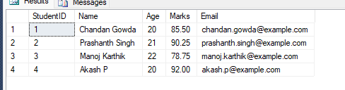

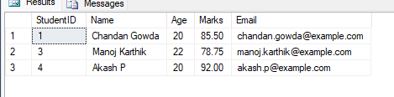

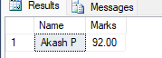

PROGRAM 2:
IMPLEMENTATION OF DIFFERENT TYPES OF FUNCTION WITH SUITABLE EXAMPLES
- NUMBER FUNCTION
- AGGREGATE FUNCTION
- CHARACTER FUNCTION
- CONVERSION FUNCTION DATE FUNCTION.
-- =========================================================

-- =========================================================
-- 1?? Create sample table for functions CREATE TABLE Orders (
OrderID INT,
ProductName VARCHAR(50), Quantity INT,
Price DECIMAL(10,2),
OrderDate DATE

); GO

-- Insert sample data
INSERT INTO Orders VALUES
(1, 'Laptop', 2, 55000.00, '2025-05-10'),
(2, 'Mouse', 5, 500.00, '2025-05-15'),
(3, 'Keyboard', 3, 1500.00, '2025-06-01'); GO

-- ? Display Orders table SELECT * FROM Orders; GO

-- =========================================================
-- 2?? Create Employee table for aggregate functions CREATE TABLE Employee (
EmpID INT PRIMARY KEY,

EmpName VARCHAR(50),
Department VARCHAR(50), Salary DECIMAL(10,2)
);

GO

-- Insert sample data
INSERT INTO Employee VALUES
(1, 'Chandan Gowda', 'IT', 50000),
(2, 'Prashanth Singh', 'HR', 45000),
(3, 'Manoj Karthik', 'Finance', 60000),
(4, 'Akash P', 'IT', 55000); GO

-- ? Display Employee table SELECT * FROM Employee; GO

-- =========================================================
-- a) ?? Number Function Example SELECT
ABS(-25) AS AbsoluteValue, POWER(5,2) AS PowerValue, ROUND(123.456, 2) AS RoundedValue;

GO

-- =========================================================
-- b) ?? Aggregate Function Example SELECT
AVG(Salary) AS AvgSalary, SUM(Salary) AS TotalSalary, MAX(Salary) AS MaxSalary, MIN(Salary) AS MinSalary
FROM Employee; GO

-- ? Also view grouped aggregate by department SELECT
Department,
COUNT(*) AS TotalEmployees, AVG(Salary) AS AvgSalary
FROM Employee GROUP BY Department; GO

-- =========================================================
-- c) ?? Character Function Example SELECT
UPPER('sql server') AS UpperCase, LOWER('SQL SERVER') AS LowerCase,
LEN('Hello World') AS StringLength, SUBSTRING('Database', 2, 4) AS SubString;

GO

-- =========================================================
-- d) ?? Conversion Function Example SELECT
GETDATE() AS OriginalDate,
CONVERT(VARCHAR, GETDATE(), 103) AS ConvertedDate, CAST(123.45 AS INT) AS CastToInt;

GO

-- =========================================================
-- e) ?? Date Function Example SELECT
GETDATE() AS CurrentDateTime, DATEPART(YEAR, GETDATE()) AS CurrentYear,
DATENAME(MONTH, GETDATE()) AS CurrentMonth, DATEDIFF(DAY, '2025-01-01', GETDATE()) AS DaysSinceStartOfYear;

GO

-- =========================================================
-- ? Extra: Derived Column using Order table SELECT
OrderID, ProductName, Quantity, Price,
(Quantity * Price) AS TotalAmount, YEAR(OrderDate) AS OrderYear
FROM Orders;
GO

Output:
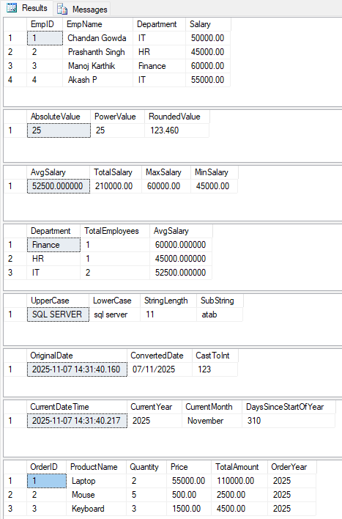

PROGRAM 3:
IMPLEMENTATION OF DIFFERENT TYPES OF OPERATORS IN SQL
- ARITHMETIC OPERATORS
- LOGICAL OPERATORS
- COMPARISON OPERATOR
- SPECIAL OPERATOR
- SET OPERATION

-- =========================================================
-- 1️⃣ Create a single table for all operator demos CREATE TABLE OperatorDemo (
EmpID INT PRIMARY KEY, EmpName VARCHAR(50️), Gender VARCHAR(1️0️),
Age INT,
Salary DECIMAL(1️0️,2), Num1️ INT,
Num2 INT

); GO

-- Insert sample data
INSERT INTO OperatorDemo VALUES
(1️, 'Chandan Gowda', 'Male', 28, 550️0️0️, 1️0️, 5), (2, 'Prashanth Singh', 'Male', 35, 450️0️0️, 20️, 3),
(3, 'Manoj Karthik', 'Male', 42, 60️0️0️0️, 1️5, 7),
(4, 'Akash P', 'Male', 25, 30️0️0️0️, 8, 2),
(5, 'Jasmine', 'Female', 30️, 40️0️0️0️, 1️2, 4),
(6, 'Alice', 'Female', 28, 270️0️0️, 7, 5); GO

-- ✅ Display table
SELECT * FROM OperatorDemo; GO

-- =========================================================
-- 2⃣ Arithmetic Operators SELECT
Num1️ + Num2 AS Addition, Num1️ - Num2 AS Subtraction, Num1️ * Num2 AS Multiplication, Num1️ / Num2 AS Division, Num1️ % Num2 AS Modulus, EmpName
FROM OperatorDemo;

GO

-- =========================================================
-- 3⃣ Logical Operators
-- Salary > 30️0️0️0️ AND Age < 40️ SELECT * FROM OperatorDemo WHERE Salary > 30️0️0️0️ AND Age < 40️; GO

-- =========================================================
-- 4⃣ Comparison Operators
-- Age >= 30️ AND Salary <> 50️0️0️0️ SELECT * FROM OperatorDemo
WHERE Age >= 30️ AND Salary <> 50️0️0️0️; GO

-- =========================================================
-- 5⃣ Special Operators

-- LIKE, BETWEEN, IN
SELECT * FROM OperatorDemo
WHERE EmpName LIKE 'J%' -- Names starting with J OR Salary BETWEEN 20️0️0️0️ AND 40️0️0️0️
OR Age IN (25, 30️, 35); GO

-- =========================================================
-- 6⃣ Set Operations
-- Using self-selects for demonstration (UNION, INTERSECT, EXCEPT)
-- Only Names and Gender for set operations
SELECT EmpName FROM OperatorDemo WHERE Gender = 'Male' AND Age < 35 UNION
SELECT EmpName FROM OperatorDemo WHERE Gender = 'Female' AND Salary > 30️0️0️0️;

GO

SELECT EmpName FROM OperatorDemo WHERE Gender = 'Male' AND Age < 35 INTERSECT
SELECT EmpName FROM OperatorDemo WHERE Gender = 'Female' AND Salary > 30️0️0️0️;

GO

SELECT EmpName FROM OperatorDemo WHERE Gender = 'Male' AND Age < 35 EXCEPT
SELECT EmpName FROM OperatorDemo WHERE Gender = 'Female' AND Salary > 30️0️0️0️;
GO

Output:
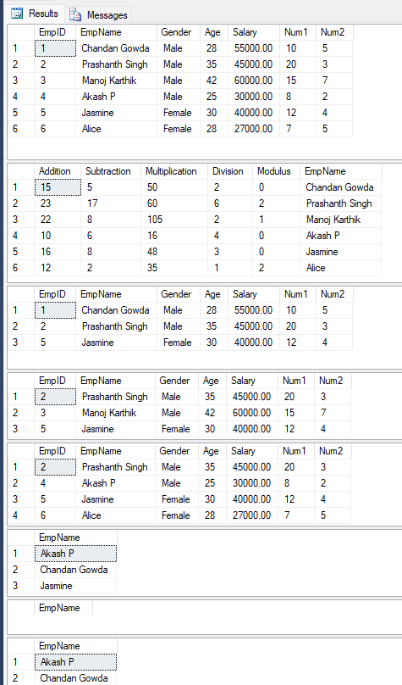

PROGRAM 4:
CREATE A TABLE FOR EMPLOYEE DETAILS WITH EMPLOYEE NUMBER AS PRIMARY KEY AND FOLLOWING FIELDS: NAME, DESIGNATION, GENDER, AGE, DATE OF JOINING AND SALARY.
- INSERT AT LEAST TEN ROWS
- GROUP BY & HAVING CLAUSE
- ORDER BY CLAUSE
- INDEXING

-- =========================================================
-- 🔹 Create and Use Database

-- =========================================================
-- a) Create EmployeeDetails table CREATE TABLE EmployeeDetails (
EmpNo INT PRIMARY KEY, Name VARCHAR(50),
Designation VARCHAR(50), Gender VARCHAR(10), Age INT,
DateOfJoining DATE, Salary DECIMAL(10,2)

); GO

-- Insert 10 rows
INSERT INTO EmployeeDetails VALUES
(1, 'John Smith', 'Manager', 'Male', 40, '2015-06-01', 60000),
(2, 'Alice Brown', 'Developer', 'Female', 28, '2019-02-15', 45000),
(3, 'Michael Lee', 'Tester', 'Male', 32, '2018-09-12', 35000),
(4, 'Sara Khan', 'HR', 'Female', 35, '2016-11-10', 40000),
(5, 'David Clark', 'Developer', 'Male', 29, '2020-01-05', 42000),
(6, 'Emma Watson', 'Developer', 'Female', 26, '2021-03-17', 39000),
(7, 'Noah James', 'Manager', 'Male', 45, '2013-07-23', 70000),
(8, 'Sophia Patel', 'Tester', 'Female', 31, '2017-08-30', 36000),

(9, 'Liam Wilson', 'Developer', 'Male', 27, '2022-04-14', 41000),
(10, 'Olivia Green', 'HR', 'Female', 38, '2014-12-01', 43000); GO

-- ✅ Display all employees SELECT * FROM EmployeeDetails; GO

-- =========================================================
-- b) Group By & Having
SELECT Designation, AVG(Salary) AS AvgSalary FROM EmployeeDetails
GROUP BY Designation HAVING AVG(Salary) > 40000; GO

-- =========================================================
-- c) Order By
SELECT * FROM EmployeeDetails ORDER BY Salary DESC;

GO

-- =========================================================
-- d) Indexing
CREATE INDEX idx_empdetails_name ON EmployeeDetails(Name); CREATE INDEX idx_empdetails_salary ON EmployeeDetails(Salary); GO

-- ✅ Example queries using the indexes SELECT * FROM EmployeeDetails WHERE Name = 'Alice Brown';

SELECT * FROM EmployeeDetails WHERE Salary > 45000
ORDER BY Salary DESC;

Output:

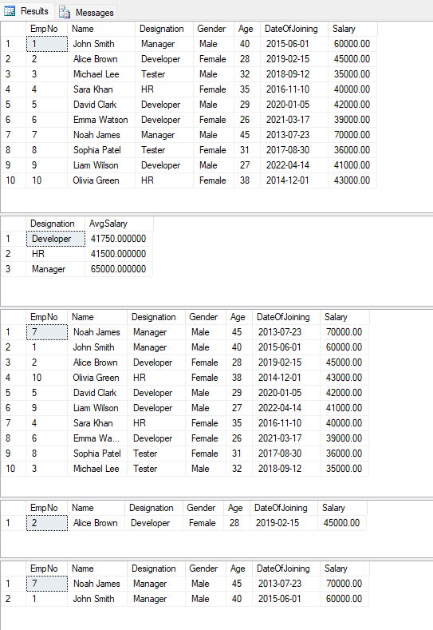

PROGRAM 5:
CREATE STUDENT, SUBJECT, INTERNAL_MARK AND EXTERNAL_MARK TABLE AND PERFORM THE FOLLOWING OPERATIONS
- ADD, EDIT, DELETE STUDENT RECORDS.
- ADD, EDIT, DELETE SUBJECT DETAILS
- INPUT INTERNAL AND EXTERNAL MARKS FOR STUDENTS IN VARIOUS SUBJECTS AND ASSESSMENTS.
- VIEW INDIVIDUAL STUDENT MARKS, SUBJECT-WISE MARKS, OR AGGREGATED RESULTS.

-- =========================================================
-- 1️⃣ Create Tables with new names

-- Student table → StudentInfo CREATE TABLE StudentInfo (
StudentID INT PRIMARY KEY, RegNo NVARCHAR(20), FullName NVARCHAR(100), Gender NVARCHAR(10),

DOB DATE,
Department NVARCHAR(50)

); GO

-- Subject table → SubjectInfo CREATE TABLE SubjectInfo (
SubjectID INT PRIMARY KEY,
SubjectCode NVARCHAR(20), Title NVARCHAR(100),
Credits INT

); GO

-- Internal Marks → InternalScores CREATE TABLE InternalScores (

StudentID INT, SubjectID INT, AssessmentNo INT,
MarksObtained DECIMAL(5,2)
);

GO

-- External Marks → ExternalScores CREATE TABLE ExternalScores (
StudentID INT, SubjectID INT, AttemptNo INT,
MarksObtained DECIMAL(5,2), ExamDate DATE

); GO

-- =========================================================
-- 2⃣ Add Students
INSERT INTO StudentInfo VALUES (1,'23CSE001','Chandan Gowda','M','2005-01- 15','CSE');
INSERT INTO StudentInfo VALUES (2,'23CSE002','prashant singh','m','2005-05- 22','CSE');
INSERT INTO StudentInfo VALUES (3,'23ECE003','manoj karthik','M','2004-11- 05','ECE');

GO

-- Edit Student
UPDATE StudentInfo SET FullName = 'Noel M. Mathew' WHERE RegNo = '23CSE001'; GO

-- Delete Student
DELETE FROM StudentInfo WHERE RegNo = '23ECE003'; GO

-- =========================================================
-- 3⃣ Add Subjects
INSERT INTO SubjectInfo VALUES (1,'CS101','Programming Fundamentals',4); INSERT INTO SubjectInfo VALUES (2,'CS102','Data Structures',4);

GO

-- Edit Subject
UPDATE SubjectInfo SET Title = 'Data Structures and Algorithms' WHERE SubjectCode

= 'CS102'; GO

-- Delete Subject
DELETE FROM SubjectInfo WHERE SubjectCode = 'CS101'; GO

-- =========================================================
-- 4⃣ Input Internal Marks
-- Internal Marks for Noel (3 assessments in CS101) INSERT INTO InternalScores VALUES (1,1,1,18); INSERT INTO InternalScores VALUES (1,1,2,17); INSERT INTO InternalScores VALUES (1,1,3,19);

-- Internal Marks for Wafa
INSERT INTO InternalScores VALUES (2,1,1,19); INSERT INTO InternalScores VALUES (2,1,2,18); INSERT INTO InternalScores VALUES (2,1,3,18); GO

-- =========================================================
-- 5⃣ Input External Marks
-- External Marks for Noel (CS101, attempt 1)
INSERT INTO ExternalScores VALUES (1,1,1,48,'2025-05-20');

-- External Marks for Wafa (CS101, attempt 1)

INSERT INTO ExternalScores VALUES (2,1,1,42,'2025-05-20'); GO

-- View Students
SELECT * FROM StudentInfo; GO

-- View Subjects
SELECT * FROM SubjectInfo; GO

-- =========================================================
-- 6⃣ View Internal Marks of a student
SELECT * FROM InternalScores WHERE StudentID = 1; GO

-- View External Marks of a student
SELECT * FROM ExternalScores WHERE StudentID = 1; GO

-- =========================================================
-- 7⃣ View Subject-wise Marks
SELECT * FROM InternalScores WHERE SubjectID = 1; SELECT * FROM ExternalScores WHERE SubjectID = 1; GO

-- =========================================================
-- 8⃣ View Aggregated Results (total internal & best external per student per subject) SELECT
StudentID, SubjectID,
SUM(MarksObtained) AS TotalInternal FROM InternalScores
GROUP BY StudentID, SubjectID; GO

SELECT
StudentID, SubjectID,
MAX(MarksObtained) AS BestExternal FROM ExternalScores
GROUP BY StudentID, SubjectID; GO

Output:
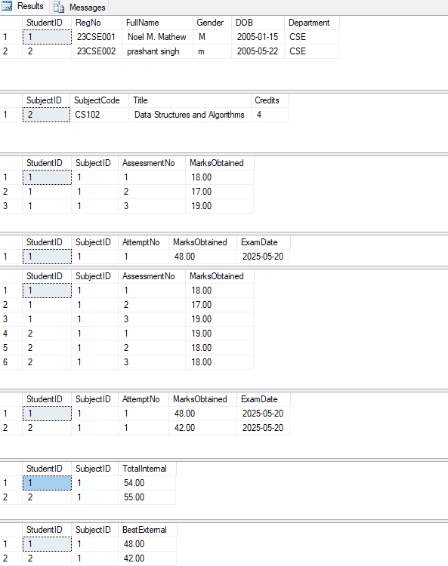

PROGRAM 6:
CREATE APPROPRIATE TABLE AND PERFORM THE FOLLOWING STRING OPERATIONS.
- CONCATENATE FIRST NAME AND LAST NAME OF STUDENTS
- CONVERT EMPLOYEE NAMES TO UPPERCASE AND LOWERCASE
- FIND EMPLOYEES WHOSE NAMES START WITH ‘A’
- FORMAT PHONE NUMBERS WITH HYPHEN (E.G., 9876543210 → 98765- 43210)
- CAPITALIZE ONLY THE FIRST LETTER OF NAMES (TITLE CASE)
- CREATE EMAIL IDS USING STUDENT FIRST NAME AND ROLL NUMBER
- VALIDATE EMAIL FORMAT USING STRING PATTERN

/* =======================================
Step 1: Create sample tables
======================================= */
CREATE TABLE Student ( RollNo INT,
FirstName NVARCHAR(50), LastName NVARCHAR(50), PhoneNo NVARCHAR(15)
);

CREATE TABLE Employee ( EmpID INT,
Name NVARCHAR(100)
);

/* =======================================
Step 2: Insert sample data
======================================= */ INSERT INTO Student VALUES
(101, 'Noel', 'Mathew', '9876543210'),
(102, 'Wafa', 'Niyas', '9876004321'),
(103, 'Ibrahim', 'Kareem', '9123456780');

INSERT INTO Employee VALUES
(1, 'Alice'),
(2, 'bob'),
(3, 'Andrew'),
(4, 'sara'),
(5, 'Amit');

name concatenation:

SELECT RollNo, FirstName + ' ' + LastName AS FullName FROM Student;

/* If you are using concat function, then*/
SELECT CONCAT(first_name, ' ', last_name) AS full_name FROM employees;

string conversion to upper and lower cases:

SELECT EmpID,
UPPER(Name) AS UpperCaseName, LOWER(Name) AS LowerCaseName
FROM Employee;

finding entries using particular values:

SELECT *
FROM Employee
WHERE Name LIKE 'A%';

formatting telephone number:

SELECT RollNo,

PhoneNo,
STUFF(PhoneNo, 6, 0, '-') AS FormattedPhone FROM Student;

capitalizing only first letter:
SELECT EmpID,
UPPER(LEFT(Name,1)) + LOWER(SUBSTRING(Name,2,LEN(Name))) AS
TitleCaseName FROM Employee;

creating email ID:
SELECT RollNo,
LOWER(FirstName) + CAST(RollNo AS NVARCHAR) + '@college.com' AS EmailID
FROM Student;

email validation:
SELECT RollNo,
LOWER(FirstName) + CAST(RollNo AS NVARCHAR) + '@college.com' AS EmailID,

CASE
WHEN LOWER(FirstName) + CAST(RollNo AS NVARCHAR) + '@college.com' LIKE '_%@_%.%' THEN 'Valid Email'
ELSE 'Invalid Email' END AS ValidationResult
FROM Student;

Output:
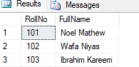

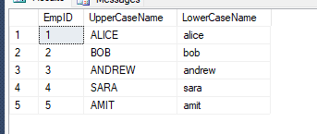

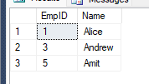

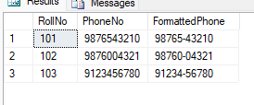

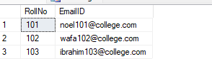

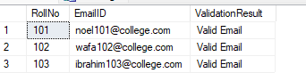

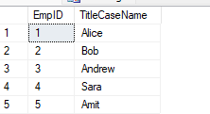

PROGRAM:7
CREATE APPROPRIATE TABLE AND PERFORM THE FOLLOWING JOIN OPERATIONS.
- LIST EMPLOYEE NAMES WITH THEIR DEPARTMENT NAMES
- DISPLAY ALL EMPLOYEES AND THEIR DEPARTMENT NAMES, INCLUDING THOSE WITHOUT A DEPARTMENT
- SHOW ALL DEPARTMENTS AND THE EMPLOYEES IN THEM, EVEN IF NO EMPLOYEES EXIST
- LIST EMPLOYEES ALONG WITH THEIR MANAGER NAMES
- LIST STUDENT NAMES, COURSE NAMES, AND FACULTY NAMES
- SHOW LIBRARY BOOK ISSUES WITH STUDENT NAMES AND DUE DATES

/* ===========================
Setup: create tables
=========================== */
CREATE TABLE Employee ( EmpID INT,
Name NVARCHAR(1️0️0️), DeptID INT,
ManagerID INT
);

CREATE TABLE Department ( DeptID INT,
DeptName NVARCHAR(1️0️0️)
);

CREATE TABLE Student ( StudentID INT,
StudentName NVARCHAR(1️0️0️)
);

CREATE TABLE Course (
CourseID INT,
CourseName NVARCHAR(1️0️0️), FacultyID INT
);

CREATE TABLE Faculty ( FacultyID INT,
FacultyName NVARCHAR(1️0️0️)
);

CREATE TABLE Enrollment ( StudentID INT,
CourseID INT
);

CREATE TABLE Book ( BookID INT,
Title NVARCHAR(20️0️)
);

CREATE TABLE LibraryIssue ( IssueID INT,
StudentID INT, BookID INT, IssueDate DATE, DueDate DATE
);

/* ===========================

Insert sample data
=========================== */

-- Departments
INSERT INTO Department VALUES (1️,'HR'); INSERT INTO Department VALUES (2,'IT');
INSERT INTO Department VALUES (3,'Marketing'); INSERT INTO Department VALUES (4,'Research');

-- Employees (some without DeptID, some without Manager)
INSERT INTO Employee VALUES (1️,'Alice Johnson',2,NULL); -- top-level manager INSERT INTO Employee VALUES (2,'Bob Kumar',2,1️); -- reports to Alice INSERT INTO Employee VALUES (3,'Charlie Lee',1️,1️); -- reports to Alice INSERT INTO Employee VALUES (4,'Diana Smith',NULL,NULL); -- no department INSERT INTO Employee VALUES (5,'Evan Brown',3,2); -- reports to Bob

-- Faculty
INSERT INTO Faculty VALUES (1️0️0️,'Dr. Ramesh'); INSERT INTO Faculty VALUES (1️0️1️,'Prof. Anita');

-- Courses (Course has a FacultyID)
INSERT INTO Course VALUES (1️0️,'Database Systems',1️0️0️); INSERT INTO Course VALUES (1️1️,'Algorithms',1️0️1️); INSERT INTO Course VALUES (1️2,'Network Security',1️0️0️);

-- Students
INSERT INTO Student VALUES (20️1️,'Noel Mathew'); INSERT INTO Student VALUES (20️2,'Wafa Niyas'); INSERT INTO Student VALUES (20️3,'Ibrahim Kareem');

-- Enrollments (student-course mapping) INSERT INTO Enrollment VALUES (20️1️,1️0️); INSERT INTO Enrollment VALUES (20️1️,1️1️); INSERT INTO Enrollment VALUES (20️2,1️0️); INSERT INTO Enrollment VALUES (20️3,1️2);

-- Books
INSERT INTO Book VALUES (30️1️,'Database Concepts'); INSERT INTO Book VALUES (30️2,'Algorithms Unlocked');

-- Library issues
INSERT INTO LibraryIssue VALUES (40️1️,20️1️,30️1️,'20️25-0️8-0️1️','20️25-0️8-21️'); INSERT INTO LibraryIssue VALUES (40️2,20️2,30️2,'20️25-0️8-0️5','20️25-0️8-25'); INSERT INTO LibraryIssue VALUES (40️3,20️3,30️1️,'20️25-0️8-1️0️','20️25-0️8-30️');

/* =========================== JOIN QUERIES
=========================== */

-- a) List employee names with their department names (only where both exist) SELECT Employee.Name, Department.DeptName
FROM Employee
INNER JOIN Department
ON Employee.DeptID = Department.DeptID;

-- b) Display all employees and their department names, including those without a department
-- (employees with no department will show NULL for DeptName)

SELECT Employee.Name, Department.DeptName FROM Employee
LEFT JOIN Department
ON Employee.DeptID = Department.DeptID;

-- c) Show all departments and the employees in them, even if no employees exist
-- (departments with no employees will show NULL for employee Name) SELECT Department.DeptName, Employee.Name
FROM Department LEFT JOIN Employee
ON Department.DeptID = Employee.DeptID ORDER BY Department.DeptName;

-- d) List employees along with their manager names (self-join)
-- We must use aliases because the same table appears twice.
SELECT e.EmpID, e.Name AS EmployeeName, m.Name AS ManagerName FROM Employee e
LEFT JOIN Employee m
ON e.ManagerID = m.EmpID;

-- e) List student names, course names, and faculty names
-- (student -> enrollment -> course -> faculty)
SELECT Student.StudentName, Course.CourseName, Faculty.FacultyName FROM Student
INNER JOIN Enrollment
ON Student.StudentID = Enrollment.StudentID INNER JOIN Course

ON Enrollment.CourseID = Course.CourseID INNER JOIN Faculty
ON Course.FacultyID = Faculty.FacultyID;

-- f) Show library book issues with student names and due dates
SELECT LibraryIssue.IssueID, Student.StudentName, Book.Title, LibraryIssue.DueDate FROM LibraryIssue
INNER JOIN Student
ON LibraryIssue.StudentID = Student.StudentID INNER JOIN Book
ON LibraryIssue.BookID = Book.BookID ORDER BY LibraryIssue.DueDate;

Output:
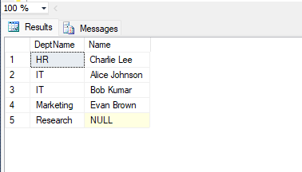
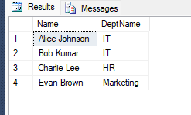
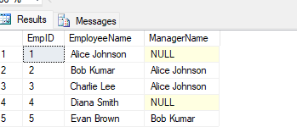
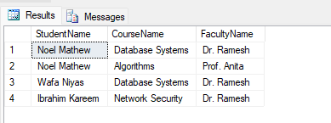
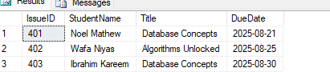

PROGRAM:8
CREATE APPROPRIATE TABLE AND PERFORM THE FOLLOWING CONDITIONAL JOIN OPERATIONS.
- LIST EMPLOYEES WHO WORK IN ‘FINANCE’ DEPARTMENT
- DISPLAY CUSTOMERS WHO HAVEN’T PLACED ANY ORDERS
- LIST ALL COURSES AND NUMBER OF STUDENTS ENROLLED IN EACH
- FIND EMPLOYEES WHO EARN MORE THAN THEIR DEPARTMENT AVERAGE SALARY
- FIND THE HIGHEST-PAID EMPLOYEE IN EACH DEPARTMENT
- FIND EMPLOYEES WHO EARN MORE THAN THEIR DEPARTMENT AVERAGE SALARY.

/* =========================
1️) SCHEMA (tables + FKs)
========================= */

-- Departments & Employees CREATE TABLE Department (
dept_id INT PRIMARY KEY,
dept_name VARCHAR(1️0️0️) UNIQUE NOT NULL
);

CREATE TABLE Employee ( emp_id INT PRIMARY KEY,
emp_name VARCHAR(1️0️0️) NOT NULL, dept_id INT NOT NULL,
salary DECIMAL(1️2,2) NOT NULL,
CONSTRAINT fk_emp_dept FOREIGN KEY (dept_id) REFERENCES Department(dept_id)
);

-- Customers & Orders

CREATE TABLE Customer ( cust_id INT PRIMARY KEY,
cust_name VARCHAR(1️0️0️) NOT NULL
);

CREATE TABLE Orders (
order_id INT PRIMARY KEY, cust_id INT NOT NULL, order_date DATE NOT NULL,
amount DECIMAL(1️2,2) NOT NULL,
CONSTRAINT fk_order_customer FOREIGN KEY (cust_id) REFERENCES Customer(cust_id)
);

-- Courses, Students, Enrollments CREATE TABLE Course (
course_id INT PRIMARY KEY,
course_name VARCHAR(1️0️0️) UNIQUE NOT NULL
);

CREATE TABLE Student ( student_id INT PRIMARY KEY,
student_name VARCHAR(1️0️0️) NOT NULL
);

CREATE TABLE Enrollment ( student_id INT NOT NULL, course_id INT NOT NULL, enroll_date DATE NOT NULL,
PRIMARY KEY (student_id, course_id),

CONSTRAINT fk_enroll_student FOREIGN KEY (student_id) REFERENCES Student(student_id),
CONSTRAINT fk_enroll_course FOREIGN KEY (course_id) REFERENCES Course(course_id)
);

/* =========================================================
2) QUERIES (Conditional Join operations as requested)
========================================================= */

-- a) List employees who work in ‘Finance’ department
-- (INNER JOIN + filter on department name)
SELECT e.emp_id, e.emp_name, d.dept_name, e.salary FROM Employee e
JOIN Department d ON d.dept_id = e.dept_id WHERE d.dept_name = 'Finance';

-- b) Display customers who haven’t placed any orders
-- (LEFT JOIN and NULL check OR use NOT EXISTS; both shown)
-- Using LEFT JOIN:
SELECT c.cust_id, c.cust_name FROM Customer c
LEFT JOIN Orders o ON o.cust_id = c.cust_id WHERE o.order_id IS NULL;

-- Equivalent using NOT EXISTS:
-- SELECT c.cust_id, c.cust_name
-- FROM Customer c
-- WHERE NOT EXISTS (SELECT 1️ FROM Orders o WHERE o.cust_id = c.cust_id);

-- c) List all courses and number of students enrolled in each

-- (LEFT JOIN so courses with zero enrollments still appear) SELECT
c.course_id, c.course_name,
COUNT(ez.student_id) AS students_enrolled FROM Course c
LEFT JOIN Enrollment ez ON ez.course_id = c.course_id GROUP BY c.course_id, c.course_name
ORDER BY c.course_id;

-- d) Find employees who earn more than their department average salary
-- (JOIN to a department-level aggregate)
SELECT e.emp_id, e.emp_name, d.dept_name, e.salary, avg_tbl.avg_salary FROM Employee e
JOIN Department d ON d.dept_id = e.dept_id JOIN (
SELECT dept_id, AVG(salary) AS avg_salary FROM Employee
GROUP BY dept_id
) avg_tbl ON avg_tbl.dept_id = e.dept_id WHERE e.salary > avg_tbl.avg_salary ORDER BY d.dept_name, e.salary DESC;

-- e) Find the highest-paid employee in each department
-- (JOIN to a department-level MAX; returns all ties if any) SELECT e.emp_id, e.emp_name, d.dept_name, e.salary FROM Employee e
JOIN Department d ON d.dept_id = e.dept_id JOIN (
SELECT dept_id, MAX(salary) AS max_salary

FROM Employee GROUP BY dept_id
) mx ON mx.dept_id = e.dept_id AND e.salary = mx.max_salary ORDER BY d.dept_name, e.emp_id;

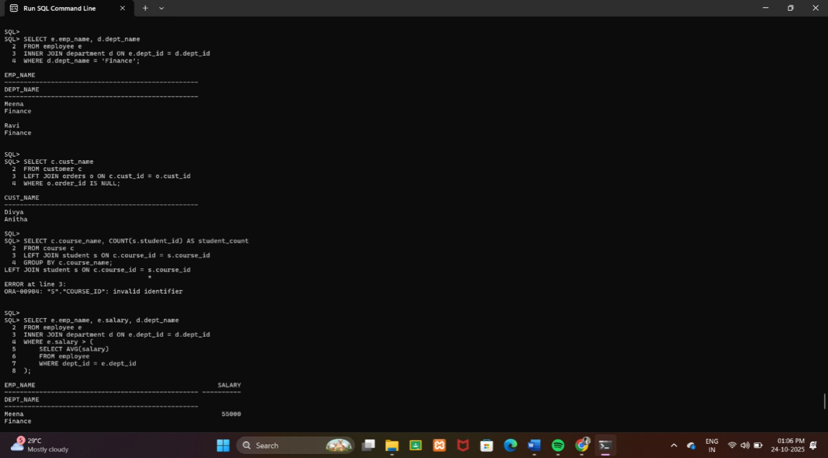
Output:

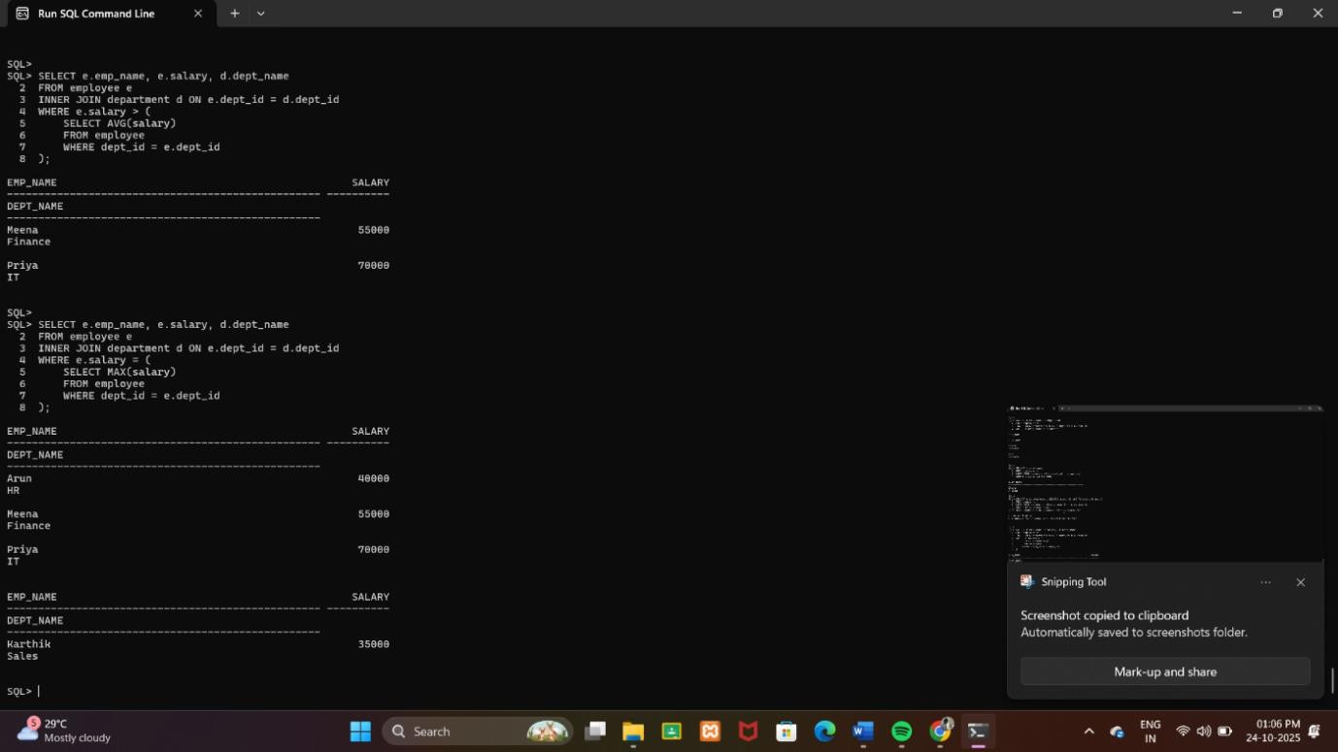

PROGRAM:9
CREATE TEACHER TABLE WITH THE FOLLOWING FIELDS
(NAME, DEPT_NO, DATE OF JOINING, DEPT_NAME, LOCATION, SALARY)
- INSERT TEN RECORDS
- GIVE INCREMENT OF 25% SALARY FOR MATHEMATICS DEPARTMENT.
- PERFORM ROLLBACK COMMAND
- GIVE INCREMENT OF 15% SALARY FOR COMMERCE DEPARTMENT
- PERFORM COMMIT COMMAND
- PERFORM SAVE POINT

-- 1) Create table
CREATE TABLE Teacher ( Name VARCHAR(50),
Dept_No INT, Date_Of_Joining DATE, Dept_Name VARCHAR(50), Location VARCHAR(50), Salary DECIMAL(10,2)
);

-- 2) Insert 10 Records
INSERT INTO Teacher VALUES ('Anita', 1, '2018-06-10', 'Mathematics', 'Chennai', 40000); INSERT INTO Teacher VALUES ('Rahul', 2, '2019-01-15', 'Commerce', 'Mumbai', 38000);
INSERT INTO Teacher VALUES ('Kiran', 1, '2017-12-20', 'Mathematics', 'Delhi', 45000); INSERT INTO Teacher VALUES ('Latha', 3, '2016-03-19', 'Physics', 'Kochi', 42000); INSERT INTO Teacher VALUES ('Vivek', 2, '2020-08-21', 'Commerce', 'Pune', 36000);
INSERT INTO Teacher VALUES ('Manoj', 4, '2015-11-25', 'Chemistry', 'Bangalore',46000); INSERT INTO Teacher VALUES ('Deepa', 3, '2018-04-30', 'Physics', 'Chennai', 41000);
INSERT INTO Teacher VALUES ('Sana', 1, '2019-09-14', 'Mathematics', 'Hyderabad',39000);
INSERT INTO Teacher VALUES ('Thomas',2, '2018-02-07', 'Commerce', 'Delhi', 37000);
INSERT INTO Teacher VALUES ('Priya', 4, '2017-10-11', 'Chemistry', 'Kolkata', 44000); COMMIT; -- commit initial data insert

-- 3) Give 25% increment for Mathematics department UPDATE Teacher
SET Salary = Salary * 1.25
WHERE Dept_Name = 'Mathematics';

SAVEPOINT A; -- create savepoint after math increment

-- 4) Perform ROLLBACK (rollback to undo maths increment) ROLLBACK;

-- 5) Give 15% increment for Commerce department UPDATE Teacher
SET Salary = Salary * 1.15 WHERE Dept_Name = 'Commerce';

-- 6) Perform COMMIT COMMIT;

-- Extra Save point after commit SAVEPOINT B;

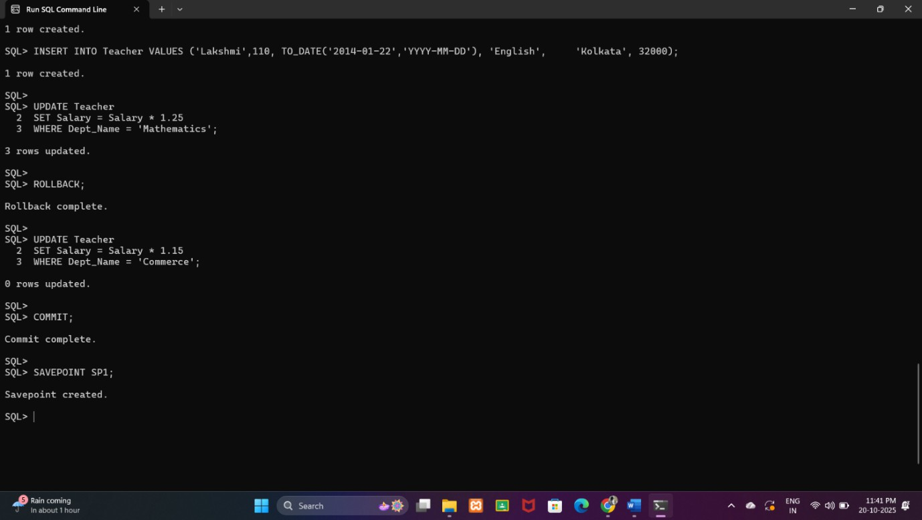
Output:

PROGRAM:10
WRITE A MYSQL PROGRAM TO DEMONSTRATE CURSORS.

To demonstrate how to use Cursors in MySQL to process each row from a table one-by-one.

Example Program: Cursor Demonstration Suppose we have a table Teacher with these fields:
(Name, Dept_Name, Salary)
We’ll use a cursor to fetch each teacher’s details and display or process them (e.g., print or store in another table).

Step 1️: Create and Insert Records CREATE TABLE Teacher (
Name VARCHAR(50️),
Dept_Name VARCHAR(30️), Salary DECIMAL(1️0️,2)
);

INSERT INTO Teacher VALUES
('Ravi', 'Mathematics', 50️0️0️0️), ('Meena', 'Commerce', 480️0️0️), ('Suresh', 'Physics', 520️0️0️), ('Priya', 'Mathematics', 51️0️0️0️), ('Arun', 'Commerce', 550️0️0️);

Step 2: Create a Table to Store Cursor Output (Optional) CREATE TABLE Teacher_Summary (
Teacher_Name VARCHAR(50️), Dept VARCHAR(30️),
Current_Salary DECIMAL(1️0️,2)
);

Step 3: Cursor Program DELIMITER $$

CREATE PROCEDURE Display_Teachers() BEGIN
-- Declare variables to hold cursor data DECLARE t_name VARCHAR(50️); DECLARE t_dept VARCHAR(30️);
DECLARE t_salary DECIMAL(1️0️,2);

-- Declare a flag for cursor end DECLARE done INT DEFAULT 0️;

-- Declare the cursor
DECLARE teacher_cursor CURSOR FOR
SELECT Name, Dept_Name, Salary FROM Teacher;

-- Declare handler for end of records
DECLARE CONTINUE HANDLER FOR NOT FOUND SET done = 1️;

-- Open the cursor OPEN teacher_cursor;

read_loop: LOOP
FETCH teacher_cursor INTO t_name, t_dept, t_salary;

-- Exit loop if no more records IF done = 1️ THEN
LEAVE read_loop;

END IF;

-- Example processing: insert into summary table
INSERT INTO Teacher_Summary VALUES (t_name, t_dept, t_salary);

END LOOP;

-- Close cursor
CLOSE teacher_cursor; END$$

DELIMITER ;

Step 4: Execute the Procedure CALL Display_Teachers();

Step 5: View the Results
SELECT * FROM Teacher_Summary;

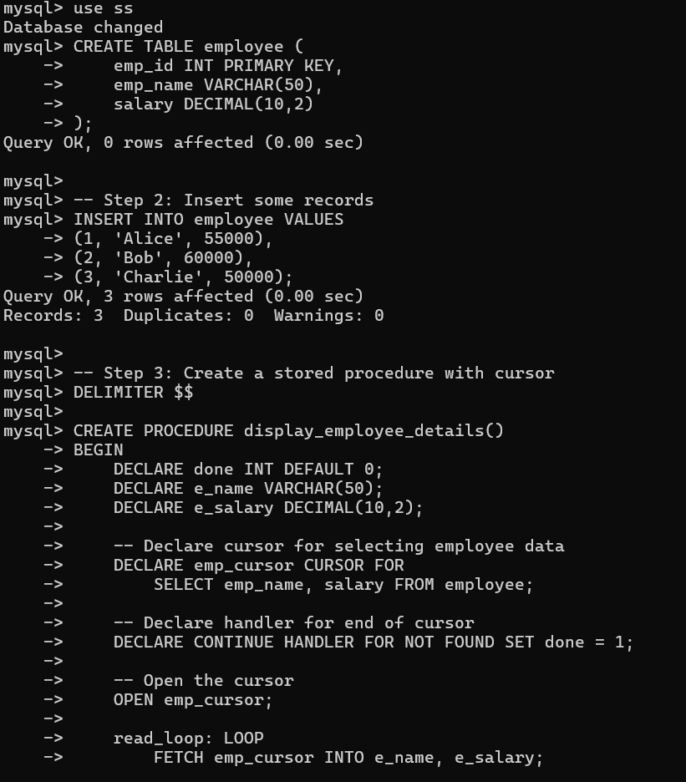
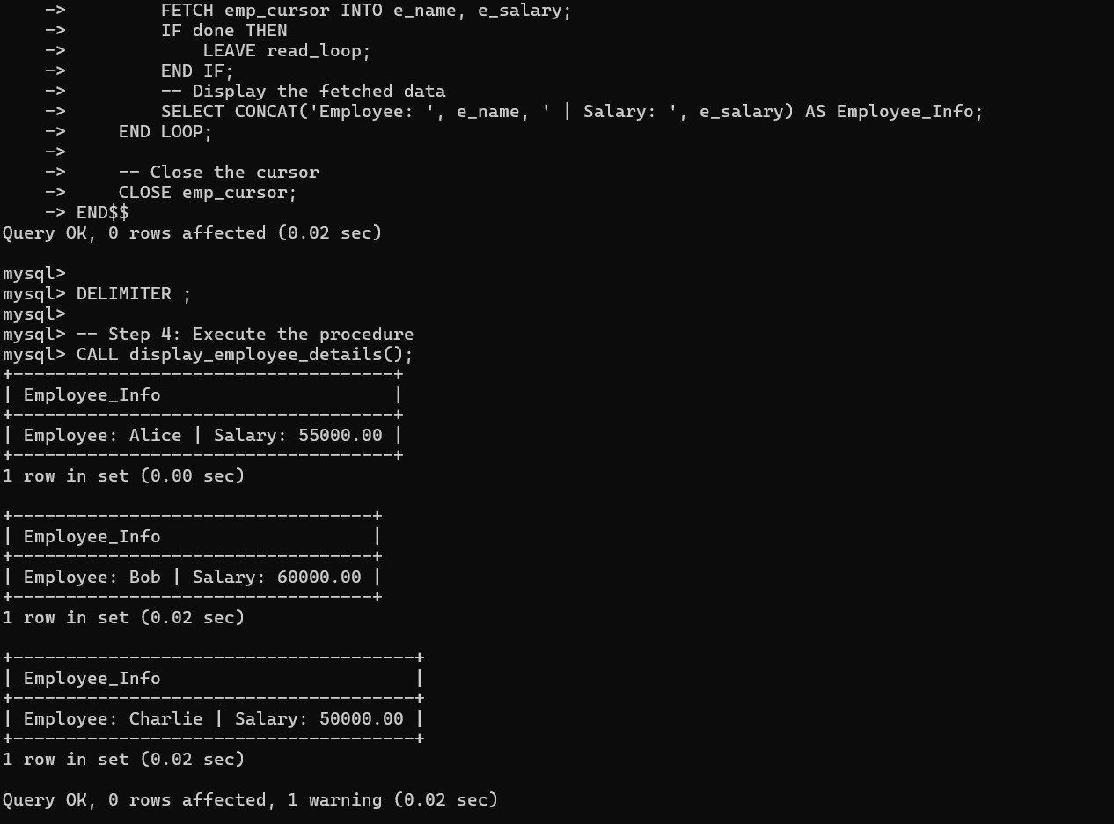
Output:

PROGRAM:11
WRITE A MYSQL PROGRAM TO DEMONSTRATE FUNCTIONS.

Step 1️: Create Database CREATE DATABASE company; USE company;
Step 2: Create Employee Table CREATE TABLE employee (
emp_id INT PRIMARY KEY, emp_name VARCHAR(50️), job_title VARCHAR(50️), salary DECIMAL(1️0️,2), hire_date DATE,
department VARCHAR(30️)
);

-- Step 3: Insert Sample Data INSERT INTO employee VALUES
(1️, 'Rahul Sharma', 'Manager', 60️0️0️0️, '20️1️9-0️5-1️2', 'HR'), (2, 'Sneha Patil', 'Developer', 450️0️0️, '20️20️-0️7-23', 'IT'),
(3, 'Amit Verma', 'Tester', 350️0️0️, '20️21️-0️2-1️5', 'QA'), (4, 'Neha Singh', 'Developer', 470️0️0️, '20️1️8-1️1️-30️', 'IT'), (5, 'Vikram Rao', 'Clerk', 250️0️0️, '20️22-0️3-25', 'Admin');

-- Step 4: String Functions
-- Display employee names in uppercase
SELECT emp_name, UPPER(emp_name) AS Upper_Name FROM employee;

-- Display first 3 letters of each employee name

SELECT emp_name, LEFT(emp_name, 3) AS Short_Name FROM employee;

-- Step 5: Numeric Functions
-- Calculate 1️0️% bonus for each employee
SELECT emp_name, salary, (salary * 0️.1️0️) AS Bonus FROM employee;

-- Round the salary to the nearest thousand
SELECT emp_name, salary, ROUND(salary, -3) AS Rounded_Salary FROM employee;

-- Step 6: Date Functions
-- Find the year and month of joining for each employee
SELECT emp_name, YEAR(hire_date) AS Joining_Year, MONTHNAME(hire_date) AS Joining_Month FROM employee;

-- Calculate years of experience
SELECT emp_name, TIMESTAMPDIFF(YEAR, hire_date, CURDATE()) AS Experience_Years FROM employee;

-- Step 7: Aggregate Functions
-- Find total, average, maximum, and minimum salary SELECT
SUM(salary) AS Total_Salary, AVG(salary) AS Average_Salary, MAX(salary) AS Highest_Salary, MIN(salary) AS Lowest_Salary
FROM employee;

-- Step 8: Group Function
-- Display average salary department-wise
SELECT department, AVG(salary) AS Avg_Salary FROM employee GROUP BY department;

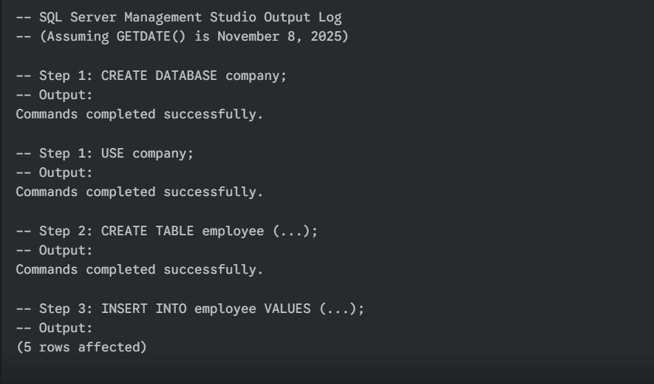
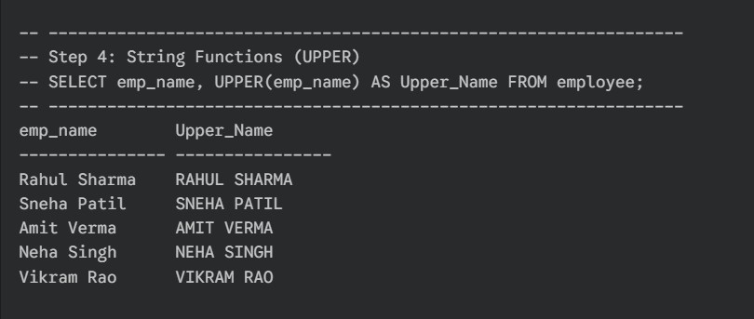
Output:

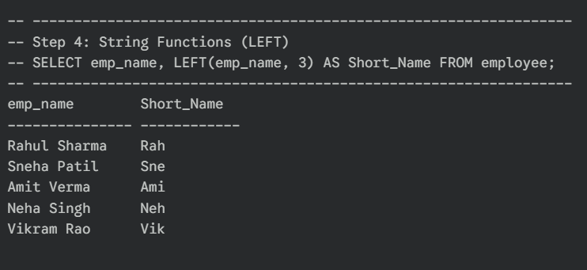
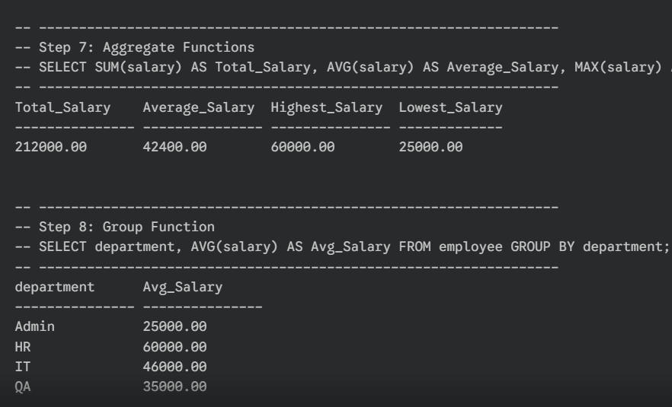

PROGRAM:12
WRITE MYSQL QUERIES TO CREATE PROCEDURES.

Step 1: Create the Employee Table
CREATE TABLE Employee (
Emp_ID INT PRIMARY KEY AUTO_INCREMENT,
Emp_Name VARCHAR(50️), Dept_Name VARCHAR(50️), Salary DECIMAL(1️0️,2), Join_Date DATE
);

□ Step 2: Insert Sample Data
INSERT INTO Employee (Emp_Name, Dept_Name, Salary, Join_Date) VALUES ('Anita', 'HR', 450️0️0️, '20️22-0️5-1️0️'),
('Ravi', 'IT', 60️0️0️0️, '20️21️-0️7-22'),
('Priya', 'Finance', 550️0️0️, '20️23-0️1️-1️2'),
('Kumar', 'IT', 480️0️0️, '20️20️-0️3-30️'),
('Meena', 'HR', 40️0️0️0️, '20️22-0️9-1️4');

Stored Procedure Examples
Procedure to Display All Employees

DELIMITER //

CREATE PROCEDURE GetAllEmployees() BEGIN
SELECT * FROM Employee; END //

DELIMITER ;

Call it:
CALL GetAllEmployees();

2⃣ Procedure with IN Parameter
Display employees of a particular department. DELIMITER //

CREATE PROCEDURE GetEmployeesByDept(IN dept VARCHAR(50️)) BEGIN
SELECT Emp_Name, Salary, Join_Date FROM Employee
WHERE Dept_Name = dept; END //

DELIMITER ;

Call it:
CALL GetEmployeesByDept('IT');

3⃣ Procedure with OUT Parameter
Return total number of employees in a department. DELIMITER //

CREATE PROCEDURE GetEmployeeCount( IN dept VARCHAR(50️),
OUT empCount INT

) BEGIN
SELECT COUNT(*) INTO empCount FROM Employee

WHERE Dept_Name = dept; END //

DELIMITER ;

Call it:
CALL GetEmployeeCount('HR', @count); SELECT @count;

4⃣ Procedure with INOUT Parameter
Increase salary of a given department by a certain percentage. DELIMITER //

CREATE PROCEDURE IncreaseSalary( INOUT dept VARCHAR(50️),
IN percent DECIMAL(5,2)

) BEGIN
UPDATE Employee
SET Salary = Salary + (Salary * percent / 1️0️0️) WHERE Dept_Name = dept;
END //

DELIMITER ;

Call it:
SET @d = 'IT';
CALL IncreaseSalary(@d, 1️0️);

5⃣ Procedure with IF Condition
Check if salary is above or below a threshold. DELIMITER //

CREATE PROCEDURE CheckSalaryLevel(IN empId INT) BEGIN
DECLARE empSal DECIMAL(1️0️,2);

SELECT Salary INTO empSal FROM Employee WHERE Emp_ID = empId;

IF empSal > 50️0️0️0️ THEN
SELECT 'High Salary' AS Result; ELSE
SELECT 'Average Salary' AS Result; END IF;
END //

DELIMITER ;

Call it:
CALL CheckSalaryLevel(2);

6⃣ Procedure with Cursor
Display all employee names using a cursor. DELIMITER //

CREATE PROCEDURE DisplayEmployeeNames() BEGIN
DECLARE done INT DEFAULT FALSE; DECLARE empName VARCHAR(50️);
DECLARE cur CURSOR FOR SELECT Emp_Name FROM Employee; DECLARE CONTINUE HANDLER FOR NOT FOUND SET done = TRUE;

OPEN cur;

read_loop: LOOP
FETCH cur INTO empName; IF done THEN
LEAVE read_loop;

END IF;
SELECT empName AS Employee_Name; END LOOP;

CLOSE cur;
END //

DELIMITER ;

Call it:
CALL DisplayEmployeeNames();

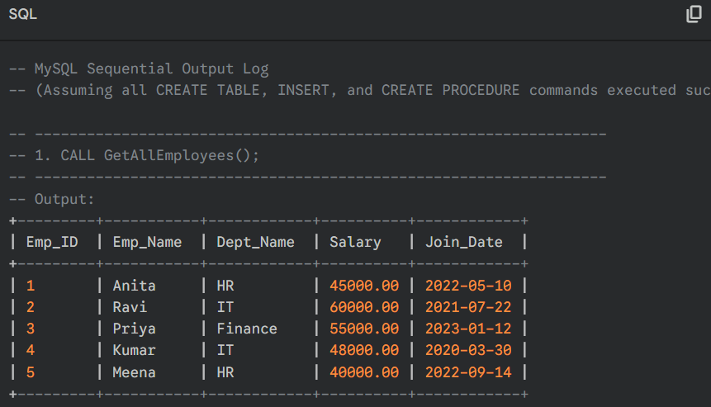
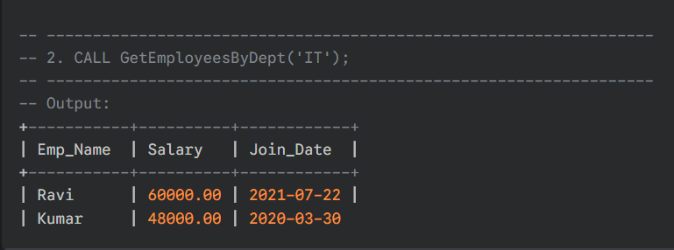
Output:

PROGRAM:13
WRITE MYSQL QUERIES TO CREATE TRIGGERS.

Basic Syntax of a Trigger
CREATE TRIGGER trigger_name

BEFORE | AFTER INSERT | UPDATE | DELETE
ON table_name FOR EACH ROW BEGIN
-- trigger logic here END;

✅ Example 1: AFTER INSERT Trigger
Let’s say you have two tables:
CREATE TABLE employees (
emp_id INT AUTO_INCREMENT PRIMARY KEY, name VARCHAR(50️),
salary DECIMAL(1️0️,2)
);

CREATE TABLE audit_log (
log_id INT AUTO_INCREMENT PRIMARY KEY,
emp_id INT,
action VARCHAR(50️),
action_time TIMESTAMP DEFAULT CURRENT_TIMESTAMP
);
Now create a trigger to log every new employee insertion: DELIMITER $$

CREATE TRIGGER after_employee_insert

AFTER INSERT ON employees FOR EACH ROW

BEGIN
INSERT INTO audit_log (emp_id, action) VALUES (NEW.emp_id, 'New Employee Added');
END $$

DELIMITER ;

Explanation:
  - AFTER INSERT → Trigger fires after a new row is inserted.
  - NEW → Refers to the new row being inserted.

✅ Example 2: BEFORE UPDATE Trigger
This trigger updates the salary only if the new salary is greater than the old one. DELIMITER $$

CREATE TRIGGER before_salary_update BEFORE UPDATE ON employees

FOR EACH ROW BEGIN
IF NEW.salary < OLD.salary THEN SIGNAL SQLSTATE '450️0️0️'
SET MESSAGE_TEXT = 'Salary cannot be decreased!'; END IF;
END $$

DELIMITER ;

Explanation:
  - BEFORE UPDATE → Fires before the update.
  - OLD → Refers to the existing row before update.

  - SIGNAL → Used to raise an error.

✅ Example 3: AFTER DELETE Trigger Log when an employee is deleted: DELIMITER $$

CREATE TRIGGER after_employee_delete AFTER DELETE ON employees

FOR EACH ROW BEGIN
INSERT INTO audit_log (emp_id, action) VALUES (OLD.emp_id, 'Employee Deleted');
END $$

DELIMITER ;

✅ Example 4: View Existing Triggers
SHOW TRIGGERS;

✅ Example 5: Drop a Trigger
DROP TRIGGER IF EXISTS after_employee_insert;

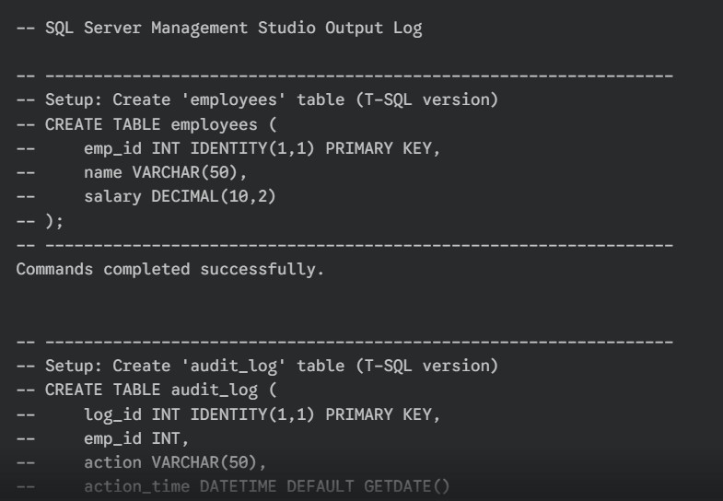
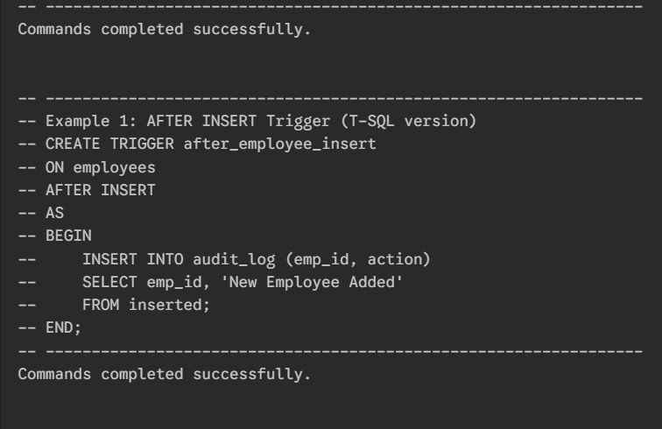
Output:

